Unlocking Insights into the global air transportation network with tableau

* **INTRODUCTION**
* **Overview**
* This global air transportation network dataset is a comprehensive collection of information on airports, airlines and their routes.
* It contains information such as names, cities, countries, codes (IATA and ICAO) longitudes, latitudes and altitudes of airports across the world with detailed time zone and daylight saving time data.
* This dataset has been compiled through meticulous labor by researchers all over the world to give you a comprehensive detail into air transportation networks from around the globe.
* **Purpose**
* Air transport is one of the fastest modes of public transport which connects international boundaries.
* Air transport allows people from different countries to cross international boundaries and travel other countries for personal, business, medical, and tourism purposes.
* **PROBLEM DEFINITION &DESIGN THINKING**
* **Empathy map**

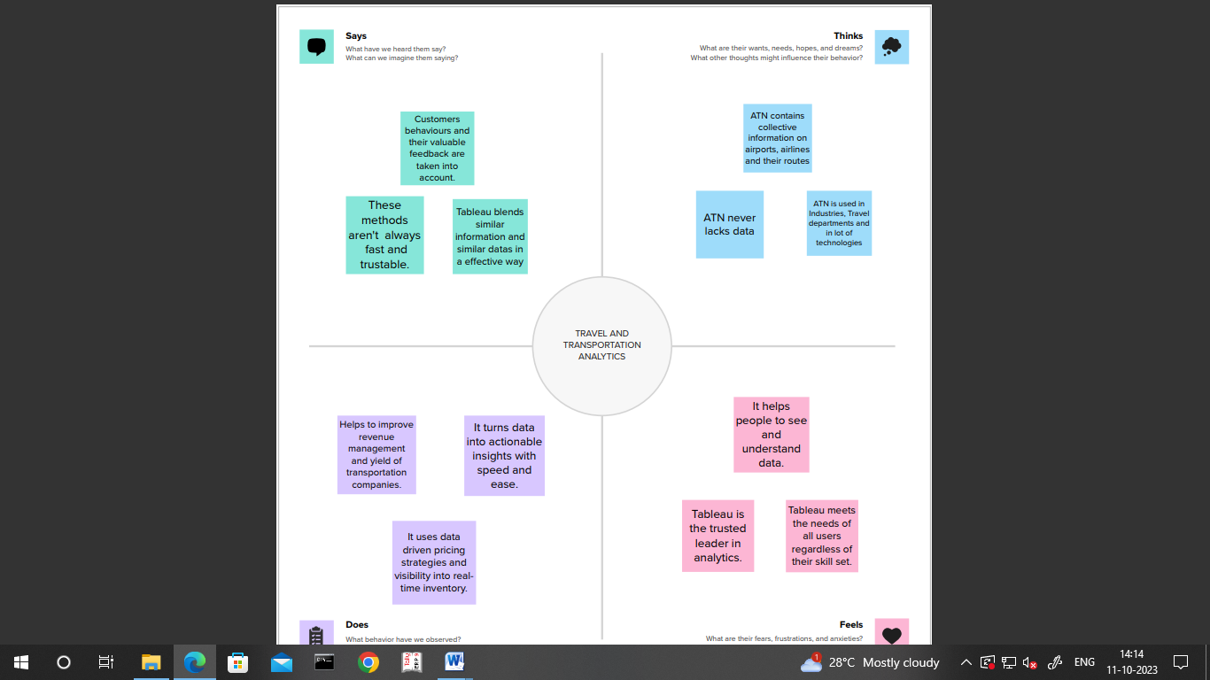

* **Ideation & brainstorming map**

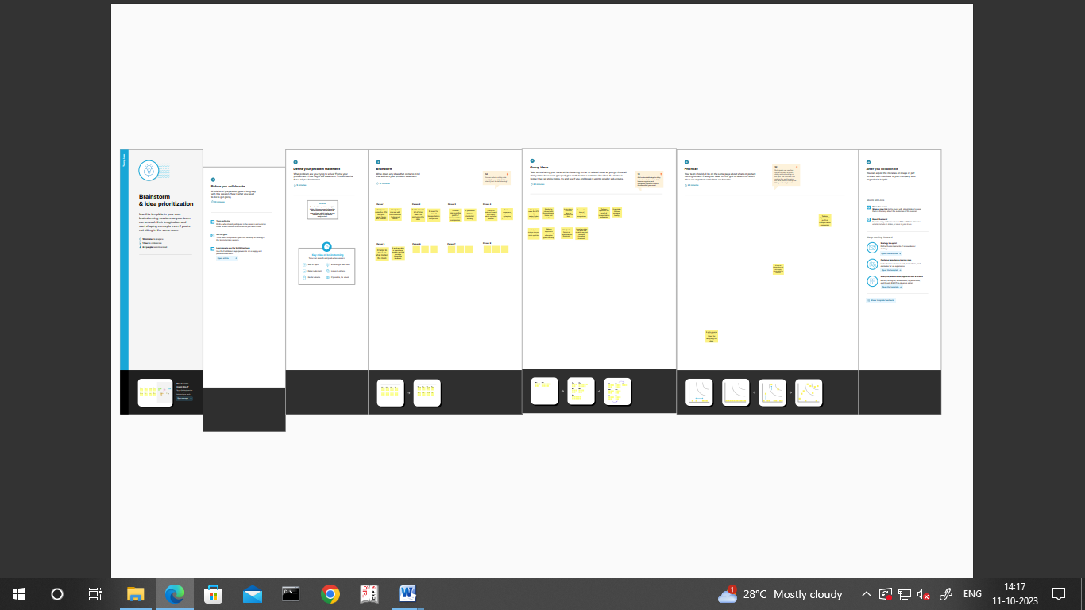

* **RESULT**
* **Dashboard 1**

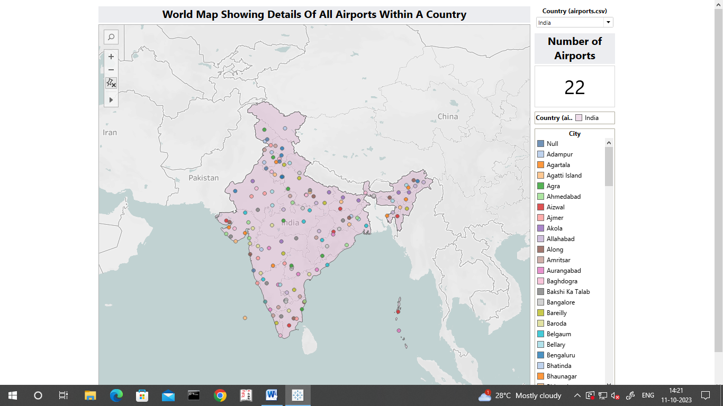

* **Dashboard 2**

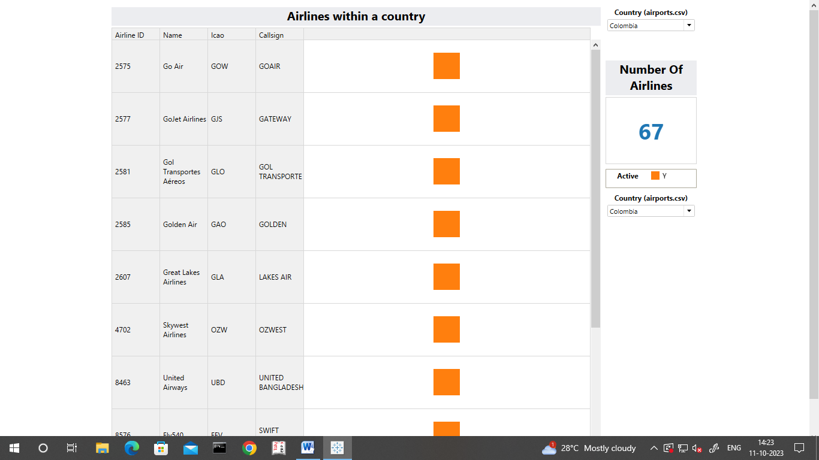

* **Dashboard 3**

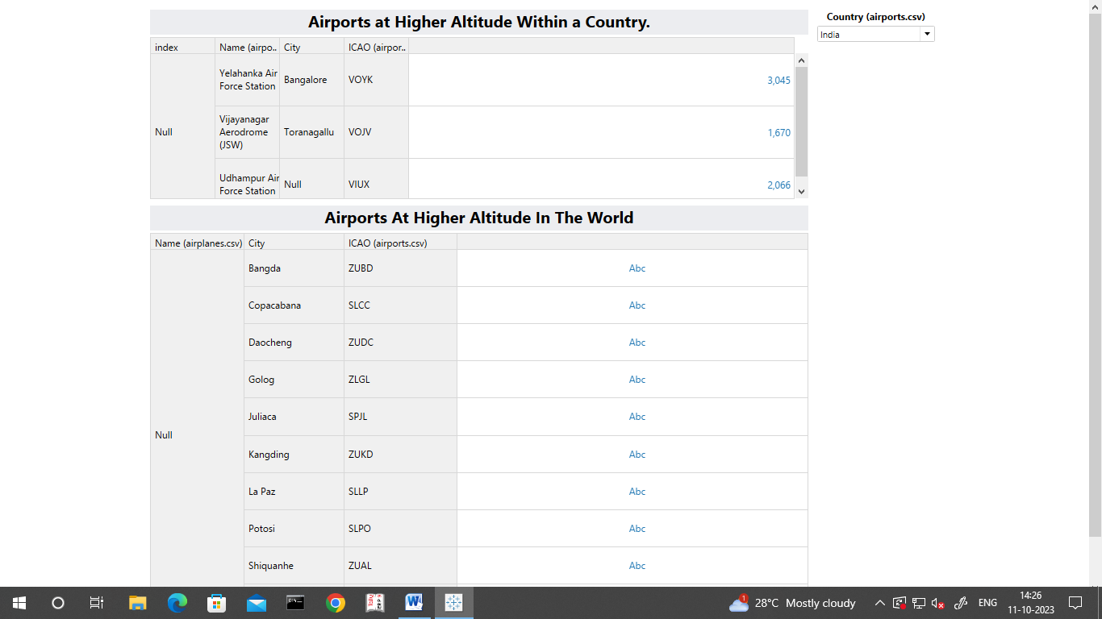

* **Dashboard 4**

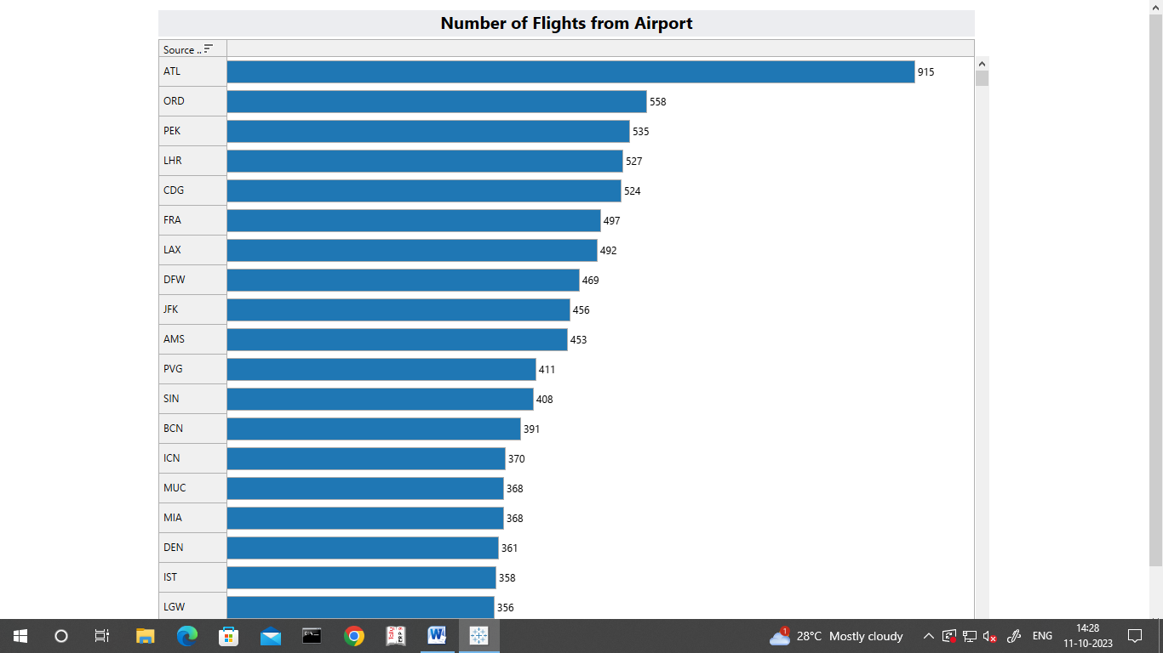

* **Story**

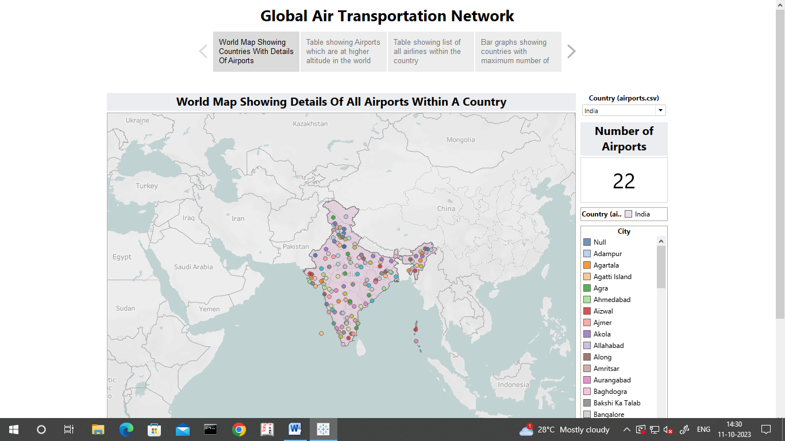

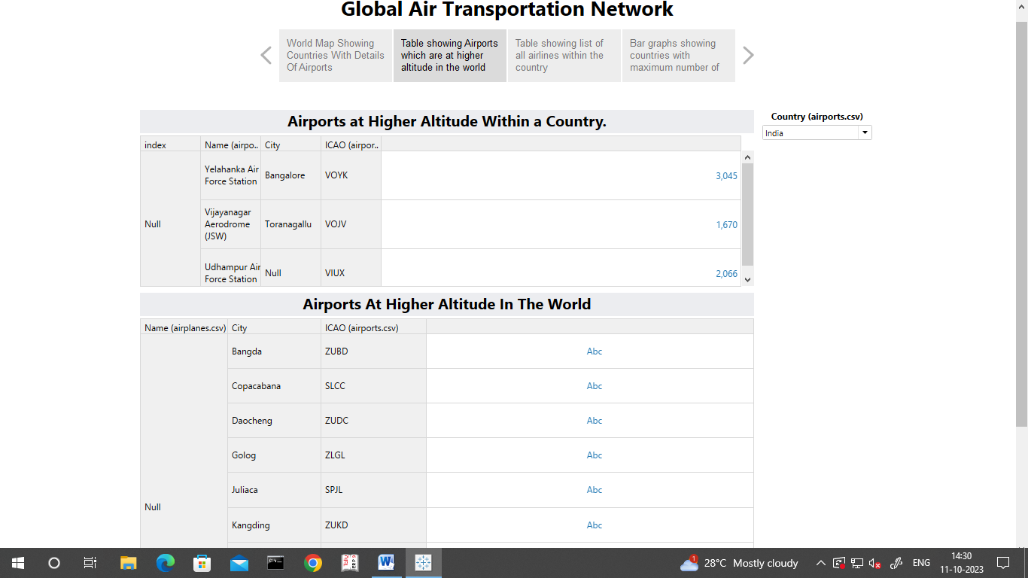

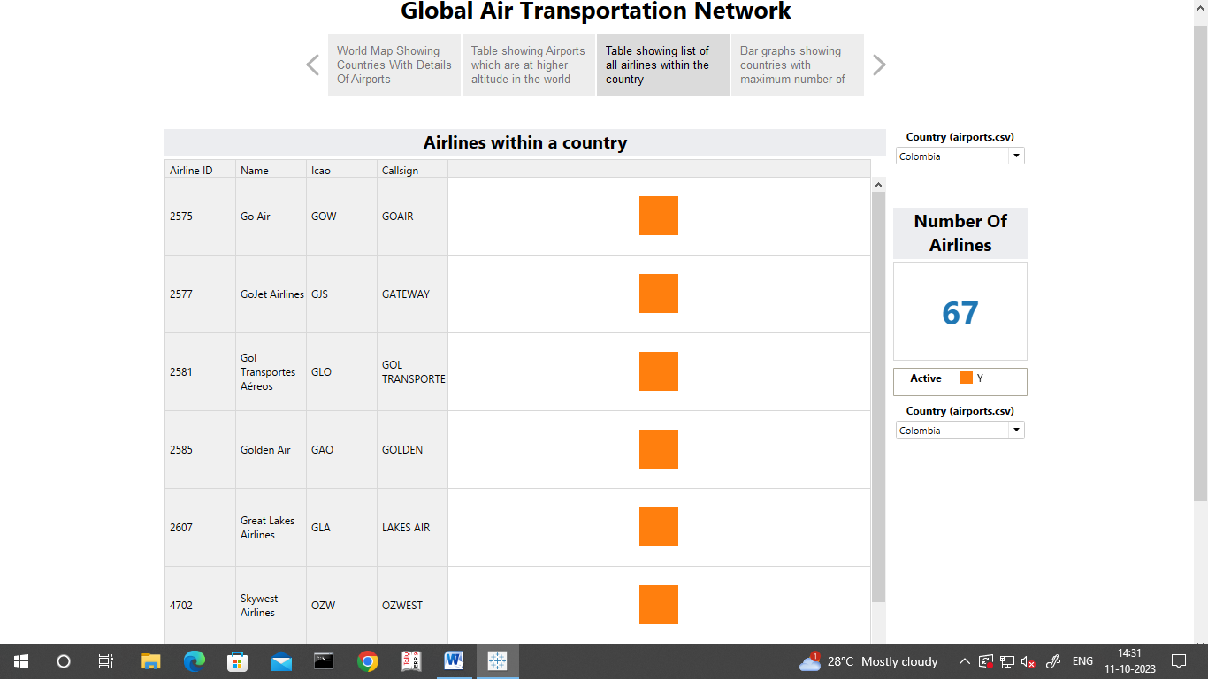

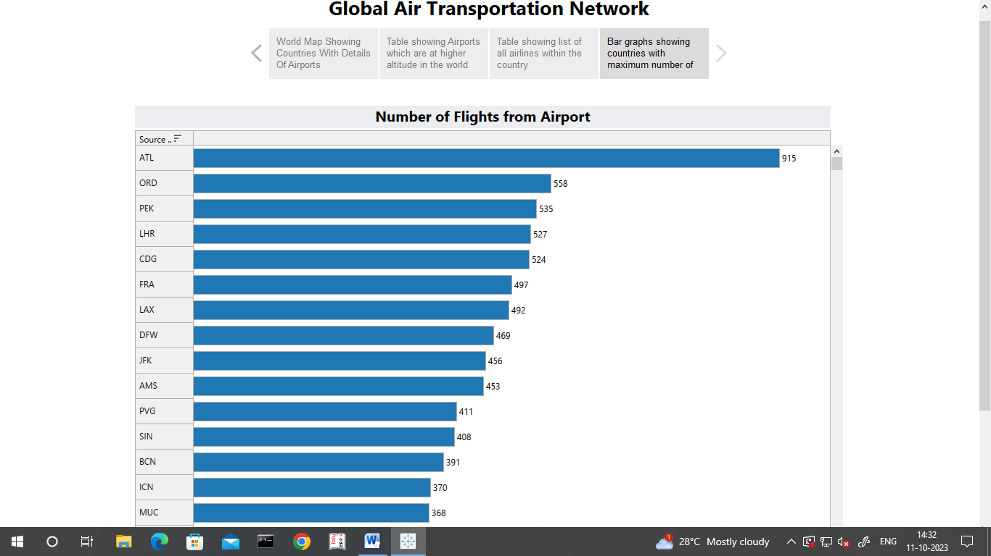

* **ADVANTAGES & DISADVANTAGES:**
* **Advantages**
* More positive passenger experiences at airports.
* Reduced cancellations and delays, improved flight tracking.
* Faster flight plans and less fuel burn in business aviation.
* Safer skies and more on-time flights.
* **Disadvantages**
* Risky, Air travel is the riskiest mode of transport, since there can be considerable losses to goods, customer and crews as a result of a minor crash.
* Cost expenses
* Some Product Limitation.
* Capacity for Small Carriage.
* Enormous investment.
* **APPLICATIONS:**
* Information technology system supports a lot of functions including reservation management, ticketing, and inventory management.
* The Airline Company has a number of branches and distributors over the globe.
* **CONCLUSION:**
* Network analysis can be used to assess the evolution of the hub-and-spoke configuration of airlines services.
* Transport geographers also play a key role in studying land use-transport interactions.
* Numerical models have been developed, which, over time, have become increasingly complex.
* **FUTURE SCOPE:**
* Experts in aviation can expect to make between INR 2 and INR 15 lakhs per year.
* Graduates who are engaged by a range of organizations have the best chances of success.
* One can quickly move from technical roles or management to hospitality services after completing training and a course.